

As partners in healthcare with Hazleton Area School District, Lehigh Valley Orthopedic Institute is pleased to offer no charge PIAA sports physicals to the athletes at your school. Starting Thursday May 1st, and concluding Sunday August 10th, physicals can be scheduled at your convenience at ExpressCARE locations throughout the region.

Instructions for scheduling your student athlete's PIAA physical are as follows:

1. Visit the [Physicals Scheduling](https://www.mylvhn.org/MyChart/openscheduling) link
2. Choose "ExpressCARE"
3. Click sports physical option
4. Select your desired time/location.

*In "reason for visit" enter the School District name*

1. Log in to your MyLVHN account or continue as guest to complete scheduling. *Continuing as a guest will require additional demographic information to be completed before scheduling*

**To schedule siblings, please visit the [Sibling Scheduling Request](https://mylvhn.org/mychart/publicforms.asp?mode=showform&formname=PIAASportsPhysical) link, fill out the form and a call team member will reach out within five to seven business days to schedule your sports physical.

Please direct any scheduling concerns to the Sports Medicine Care Coordination Team at [AthleticTraining@lvhn.org](mailto:AthleticTraining@lvhn.org)



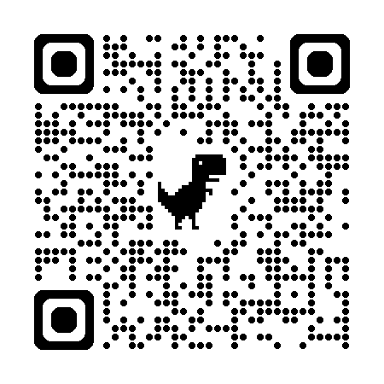

← Physicals Scheduling

Sibling Scheduling Request →

